**Brilliant Breakfasts!**

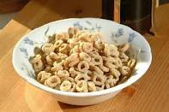

|  |  |
| --- | --- |
| **My breakfast this morning…** | **Star Rating** |
|  |  |
|  |  |
|  |  |
|  |  |

**Can you improve?**

|  |  |
| --- | --- |
| **My breakfast tomorrow could be…** | **Star Rating** |
|  |  |
|  |  |
|  |  |
|  |  |