High 5
Stage: First Level | Lesson: Physical activity and food
Health and Wellbeing Experiences and Outcomes:
HWB 1-28a
I understand that my body needs energy to function and that this comes from the food that I eat. I am exploring how physical activity contributes to my health and wellbeing.

Main Activities:
Challenge the children to think of their bodies as cars, rockets or machinery.
Explain that:
- “Everyday foods” are the best fuel to power your body and brain. (See everyday foods and sometimes foods lesson plan. If you have not already covered this lesson plan, just refer to “food” rather than “everyday foods”.)
- Cars need fuel (petrol or diesel), to get to their destination. If it’s a long journey, it will need a lot of fuel. In the same way, we need more food if we are going to be very active.
- The best fuel will help it go well. “Everyday foods” are the best fuel for people.
- Just like cars need fuel to go, we also need food to help us get up and go.
- When you eat, your body breaks down food into tiny parts. Then it goes into your blood and is carried to different parts of your body like your bones, brain, muscles and heart.
- Food gives the energy we need to think, to run around and to do what we want to do

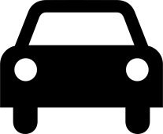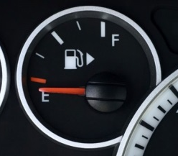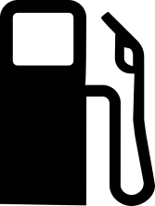

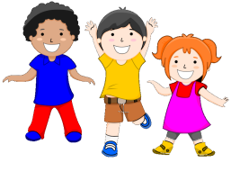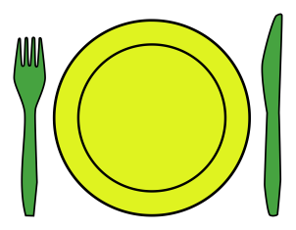
Hungry?

Use the above pictures if you feel it helps get the point across.
Consuming everyday foods helps you perform to the best of your ability, stay healthy and feel great. (To learn more about different kinds of everyday foods, see the “Eatwell Guide lesson plan”.)

Ask the children to think of a meal or a snack that would give them extra energy, when we are doing physical activity.

Ask the children if there are any other reasons why we eat, other than to give us fuel/energy? (The aim is to get them to remember that we are allowed to enjoy food simply for its taste. This is different to cars or machines!)

Choose a ‘FIT 15’ to participate in!

Extra Guidance Notes for Teachers
It is true that people who eat more food than they “burn up” from their activity, will gain extra weight over time. Making this part of the discussion may do more harm than good and could contribute to weight based stigma for heavier children.

